Assignment 3: Monitor Unencrypted S3 Buckets Using AWS Lambda and Boto3

Objective: To enhance your AWS security posture by setting up a Lambda function that detects any S3 bucket without server-side encryption.
Task: Automate the detection of S3 buckets that don't have server-side encryption enabled.
Instructions:
1. S3 Setup:
- Navigate to the S3 dashboard and create a few buckets. Ensure that a couple of them don't have server-side encryption enabled.
2. Lambda IAM Role:
- In the IAM dashboard, create a new role for Lambda.
- Attach the `AmazonS3ReadOnlyAccess` policy to this role.
3. Lambda Function:
- Navigate to the Lambda dashboard and create a new function.
- Choose Python 3.x as the runtime.
- Assign the IAM role created in the previous step.
- Write the Boto3 Python script to:
1. Initialize a boto3 S3 client.
2. List all S3 buckets.
3. Detect buckets without server-side encryption.
4. Print the names of unencrypted buckets for logging purposes.
4. Manual Invocation:
- After saving your function, manually trigger it.
- Review the Lambda logs to identify the buckets without server-side encryption.

Bucket - s3-demo-ash1
IAM role- s3-lambda

IAM Role :

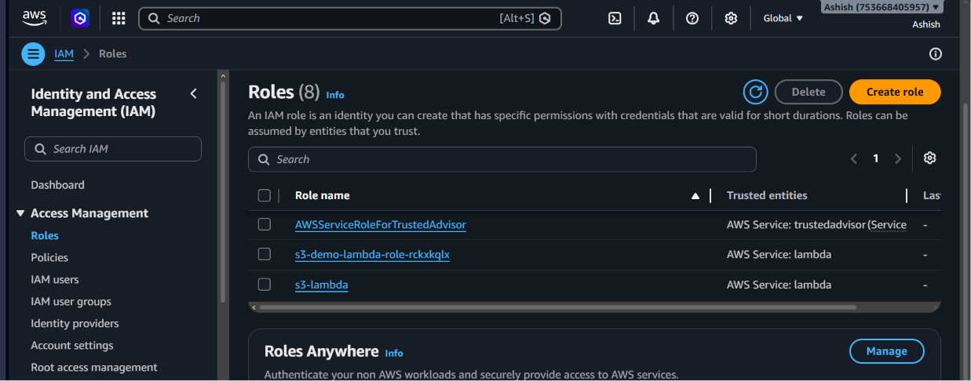
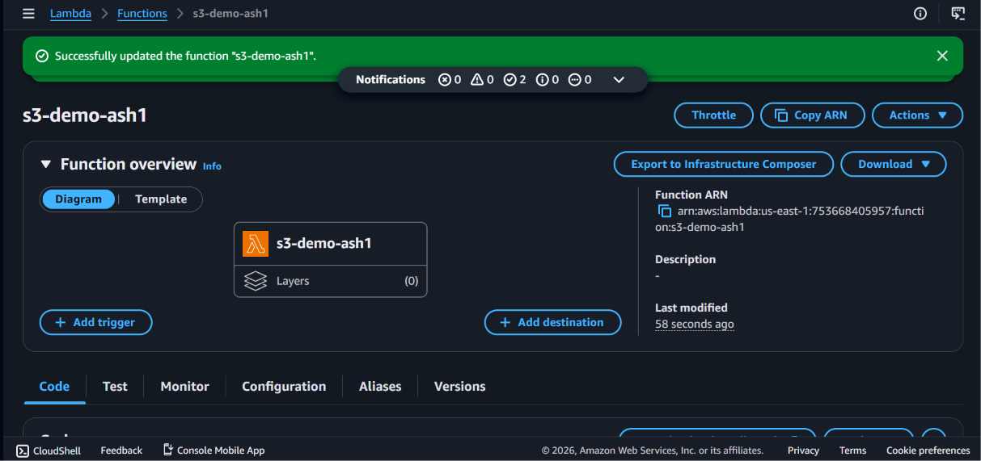

Lambda script used :
import boto3
import json

def lambda_handler(event, context):
# Initialize S3 client
s3 = boto3.client('s3', region_name='us-east-1') # adjust region if needed
unencrypted_buckets = []

# List all buckets
buckets = s3.list_buckets()['Buckets']

for bucket in buckets:
bucket_name = bucket['Name']
try:
# Try to get encryption configuration
s3.get_bucket_encryption(Bucket=bucket_name)
except s3.exceptions.ClientError as e:
# Detect missing encryption
if "ServerSideEncryptionConfigurationNotFoundError" in str(e):
unencrypted_buckets.append(bucket_name)
print(f"Bucket without encryption: {bucket_name}")

return {
'statusCode': 200,
'body': json.dumps({
'unencrypted_buckets': unencrypted_buckets
})
}

